Docker
Ahmed Ehab Ahmed
Lab-3

Problem 2:
- Create a dockerfile for ubuntu image which sleeps by default for 5 sec or sleeps according to the given number in the docker command

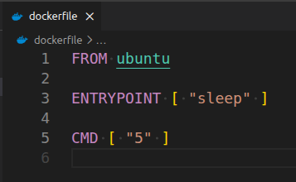
docker build -t ubuntu-sleep .

Problem 3:
- Push the images created in Problem 1&2 into your docker hub repo

docker login
docker tag ubuntu-sleep ahmedehabreffat/iti-ubuntu-sleep
docker push ahmedehabreffat/iti-ubuntu-sleep
docker tag angular-simple ahmedehabreffat/iti-angular
docker push ahmedehabreffat/iti-angular

Problem 4:
- Create 2 nginx containers with network type bridge, enter to one of them and use curl command to view the ccontent of the other container.
